System Design Document (SDD)

Project Name: GoCloak Prepared by: Sajib Jahan Date: March 16, 2025

Date | version | Prepared by | Checked by
20/03/2025 | 1.0.0 | Sajib Jahan | Masihur Maruf

1. Overview
Purpose: This System Design Document describes the architecture, component design, data flow, and security considerations for GoCloak—a lightweight, high-performance identity and access management (IAM) system written in Go. It aims to be a self-hosted alternative to Keycloak with modular REST APIs and an internal Admin Panel.
Scope: This document covers the following components:
- Admin Panel
- REST API Service
- Realm & User Management
- Token Service (OAuth2/OIDC)
- Role & Permission Management
- Database Design
- Security and Scalability Considerations

2. System Architecture Diagram
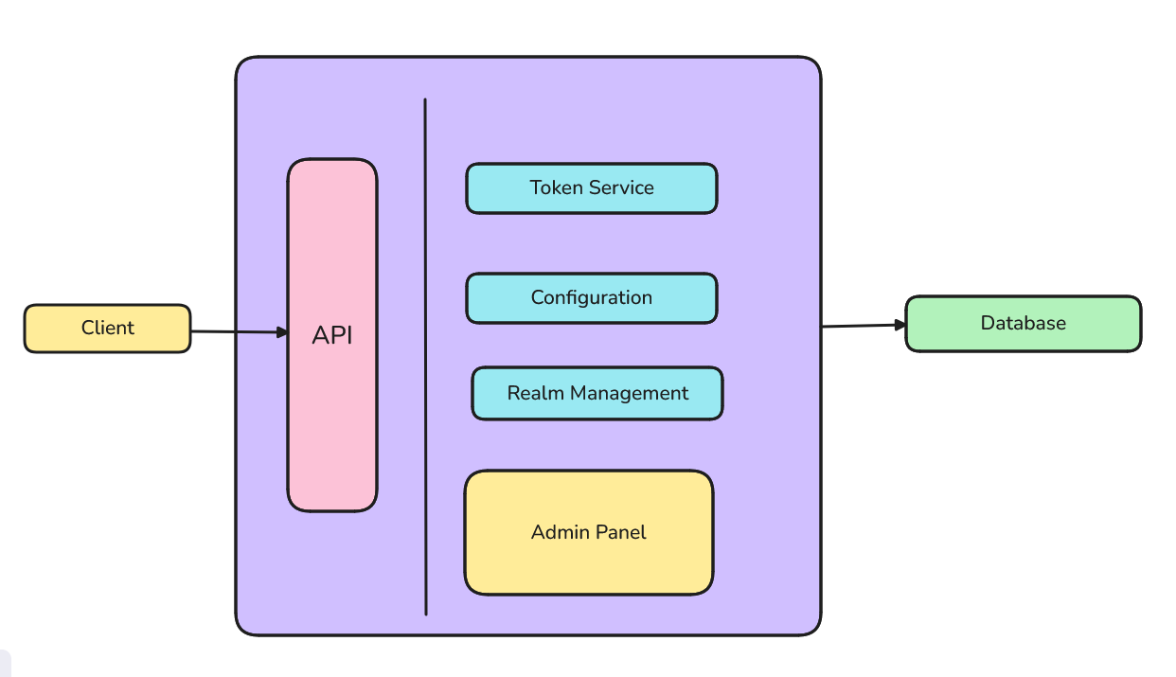
Client: Any backend machine, public frontend, mobile or device requesting IAM service
API: API endpoints that allows clients to communicate with keycloak
Admin Panel: Web based view directly built in gocloak core for managing realms & configurations
Token service: Service that facilitates token generation

3. Component Breakdown

3.1 REST API Service
- Handles external communication via REST.
- Provides endpoints for managing realms, users, roles, and clients.
- Implements OAuth2/OIDC token issuance.
- Built using Go with the Gin framework.

3.2 Admin Panel
- Internal UI for administrators.
- Uses server-side rendering or HTMX/Tailwind.
- Interacts directly with the internal API layer.
- Restricted via admin login with role-based access control.

3.3 Realm Manager
- Manages logical tenant boundaries.
- Each realm is isolated: its users, roles, clients, and settings.
- Realm configurations stored in DB.

3.4 User & Role Manager
- Handles CRUD operations for users, groups, and roles.
- Supports password reset, role assignment, and status flags.

3.5 Token Service
- Issues access tokens (JWT - RS256).
- Refresh token and introspection support.
- Validates client credentials and user login.

4. API Design
The following endpoints will be exposed by GoCloak for managing realms, clients, users, and authentication.
5.1. Realm Management
- GET /realms: List all realms (admin scope)
- POST /realms: Create a new realm
- GET /realms/{realm}: Get realm configuration
- PUT /realms/{realm}: Update realm configuration
- DELETE /realms/{realm}: Delete realm
5.2. User Management
- POST /realms/{realm}/users: Create a user
- GET /realms/{realm}/users/{id}: Get user details
- PUT /realms/{realm}/users/{id}: Update user
- DELETE /realms/{realm}/users/{id}: Delete user
5.3. Client Management
- POST /realms/{realm}/clients: Register a new client
- GET /realms/{realm}/clients: List all clients
- PUT /realms/{realm}/clients/{id}: Update client
- DELETE /realms/{realm}/clients/{id}: Delete client
5.4. Token Management
- POST /realms/{realm}/protocol/openid-connect/token: OAuth2 token endpoint
- POST /realms/{realm}/protocol/openid-connect/token/introspect: Token introspection
- GET /realms/{realm}/protocol/openid-connect/userinfo: Fetch user info from token

5. Database Design

5.1 Tables
- Realms: id, name, config_json
- Users: id, realm_id, username, password_hash, status
- Clients: id, realm_id, name, secret, redirect_uris
- Roles: id, realm_id, name, description
- UserRoles: user_id, role_id
- AuditLogs: action, performed_by, entity_type, timestamp
Database: PostgreSQL (SQLite for development mode)

7. Security Considerations
- HTTPS enforcement (TLS)
- Passwords hashed with bcrypt or argon2
- JWT signed with RS256
- Admin panel CSRF and XSS protection
- Input validation and sanitization
- RBAC for Admin Panel and API scopes

